**PSEUDO CODE**

QUESTION#1) Find if the number is multiple of 5.

* START
* // input
* INPUT number1
* // Process Steps
* SET remainder to number1%5
* //Conditional Statements
* IF remainder = 0 THEN
* PRINT “The number is multiple of 5”
* ElSE
* PRINT “The number is not a multiple of 5”
* END

QUESTION#2 Check if a character is uppercase or lowercase.

* START
* //Input
* INPUT character1
* //variables and initialization
* SET uppercase to [A,B,C,D,E,F,G,H,I,J,K,L,M,N,O,P,Q,R,S,T,U,V,W,X,Y,Z]
* SET lowercase to
* [a,b,c,d,e,f,g,h,I,j,k,l,m,n,o,p,q,r,s,t,u,v,w,x,y,z]
* // Conditional Statements
* IF character1 == uppercase THEN
* PRINT “Character is uppercase”
* ELSE
* PRINT “Character is lowercase”
* END

QUESTION#3 Create a small calculator which only does ‘+’ or ‘*‘Operations. (Hint: Take three variable inputs

with one being used for the operator)

* START
* // Input
* INPUT variable1
* INPUT variable2
* INPUT operation
* // Process Steps
* SET operation to number1 (operation) number2
* // Conditional Statements
* IF operation = + THEN
* PRINT “number1+number2”
* ELSE
* PRINT “number1*number2”
* END

QUESTION#5) Determine if a person is a teenager (between 13 and 19 years old).

* START
* //Input
* INPUT age1
* //Conditional statements
* IF age1 >= 13 && age1 <= 19 THEN
* PRINT ‘’You are a teenager”
* ELSE
* PRINT “You are not a teenager”
* END

QUESTION#4 Check whether a given number is positive, negative, or zero.

* START
* // Input
* INPUT number1
* // Conditional Statement
* IF number1=0 THEN
* PRINT “The number is equal to 0”
* ELSE
* // Conditional Statement
* IF number1>0 THEN
* PRINT “The number is positive”
* ELSE
* PRINT “The number is negative”
* END

**Algorithms**

Q5) Find the median of three given numbers.

Ask user to enter num1

Ask user to enter num2

Ask user to enter num3

Declare variable median

If num1>num2 then

Check if num2>num3 then

set num2 as median

Else then

Set num3 as median

Else then //num2 is greater than num1

If num1>num3 then

Set num1 as median

Else

Set num3 as median

Display median for the user

Q4) Calculate the area of a circle given its radius r.

Ask user to user to input radius

Set radius as r

Set area of circle to (3.14*r*r)

Display area for the user

Q3) Write an algorithm to calculate x raised to the power y (i.e., x y ) without using built-in power functions.

Ask user to input x

Ask user to input y

Set base number to “x”

Set power number to “y”

Multiply base to itself by power times

Display result

Q1) Implement an algorithm to determine if a given year is a leap year. A leap year is divisible by 4, but not divisible by 100, except if it is also divisible by 400.

Ask user to enter year

Set remainder1 as (year%4)

Set remainder2 as (year%400)

Set remainder 3 as (year%100)

If remainder1 = 0 then

Display leap year

Else display not a leap year

If remainder2 =0 then

Display leap year

Else

display not a leap year

If remainder3 = 0 then

Display not leap year

Else

Display a leap year

Q2) Implement an algorithm to count the number of occurrences of each character in a given string

Ask user to enter a string

Break string into each character

Count characters in given string

Store each different character in different variables

Count the repeated characters

Store repetition of each character into its variable

Display the occurrence of each character present in string

**FLOWCHART**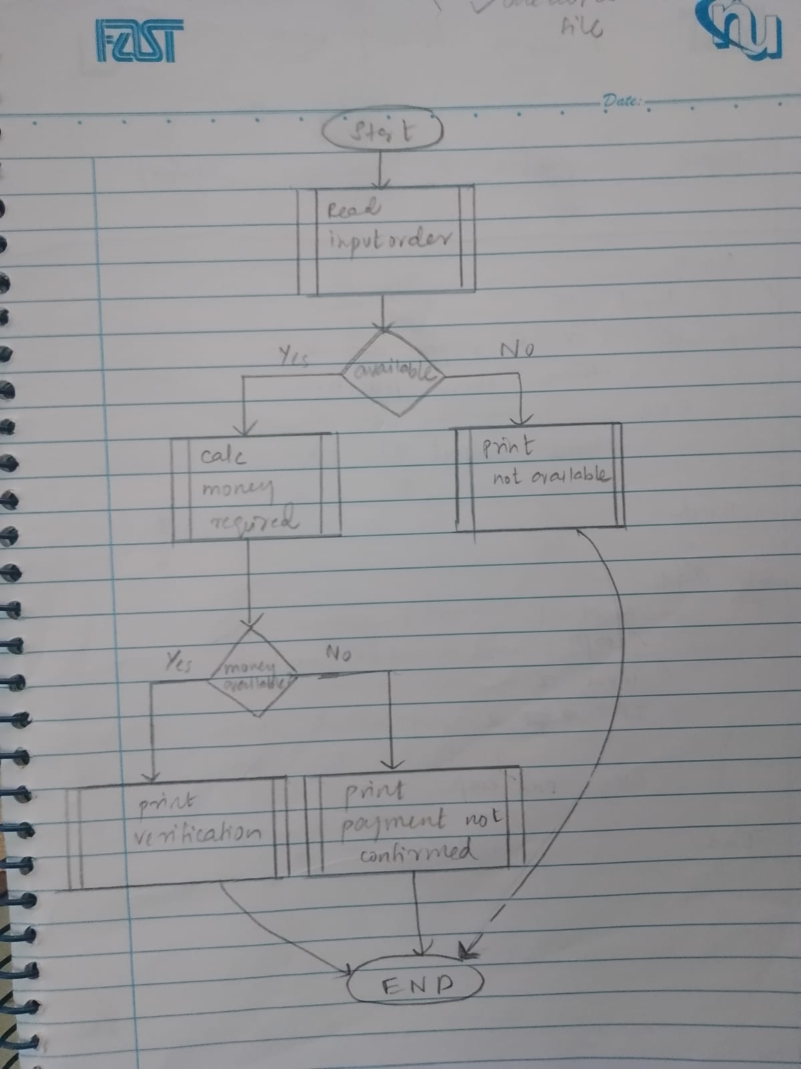

GITHUB IMAGE

